

**Assignment of**

Computer Vision

**Topic**

Convolutional Neural Networks

**Submitted to**

Dr. Mohammed Moazzam Fraz

**Submitted By**

Asmat Zahra

CMS ID: 322287

PhD-CS

**Dated: 13th Dec, 2019**

**School of Electrical Engineering and Computer Science**

**National University of Science and Technology**

**Islamabad**

# Training # 1 with Model/ Network Summary

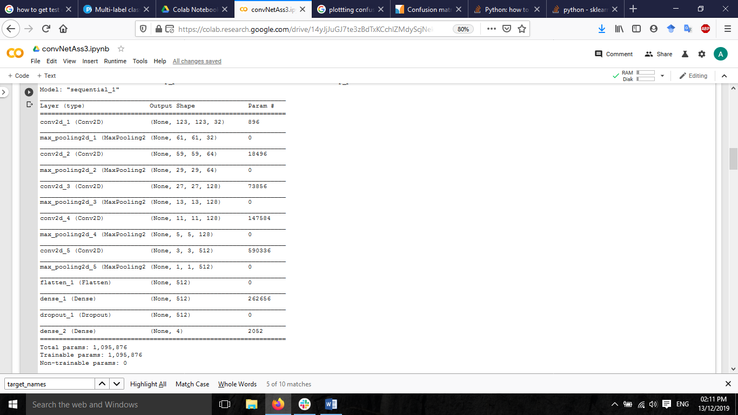First run with model summary shown In Fig. 1

Figure. 1: Model Summary

# Training Settings

|  |  |
| --- | --- |
| **Parameters** | **Value** |
| **Number of classes** | 4 |
| **Training Set** | 500 Images in each class, 500*4 |
| **Testing Set** | 200 Images in each class, 200*4 |
| **Validation Set** | 200 Images in each class, 200*4 |
| **Loss** | Categorical Cross Entropy |
| **Optimizer** | Adam |
| **Metrics** | Accuracy |
| Target size | 125,125 |
| **Steps per epoch** | 10 |
| **Number of epochs** | 10 |
| **Validation Steps** | 10 |
| **Dropout** | 0.3 |

# Confusion Matrix

Figure 2: Actual and predicted results of trained model with hyper parameters given in Table 1.

# Classification Report

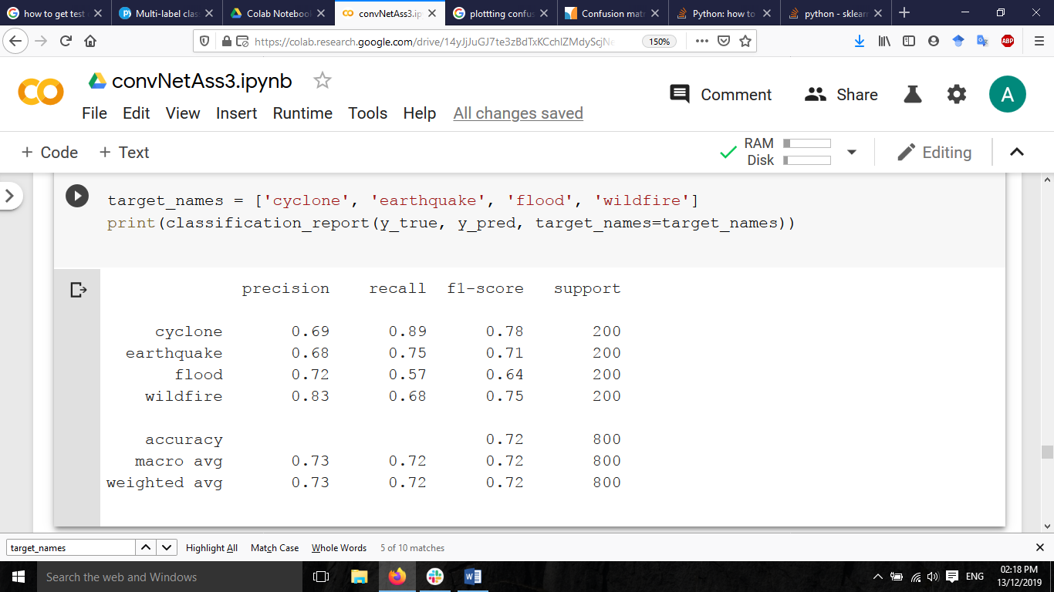

# Training and validation performance graphs

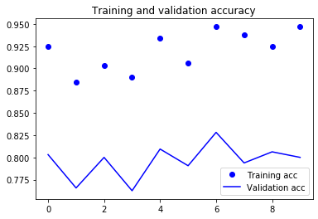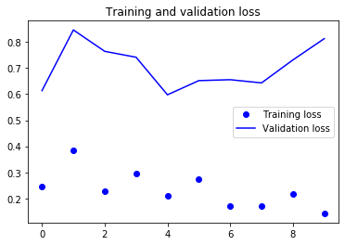

# Training # 2 with Model/ Network Summary

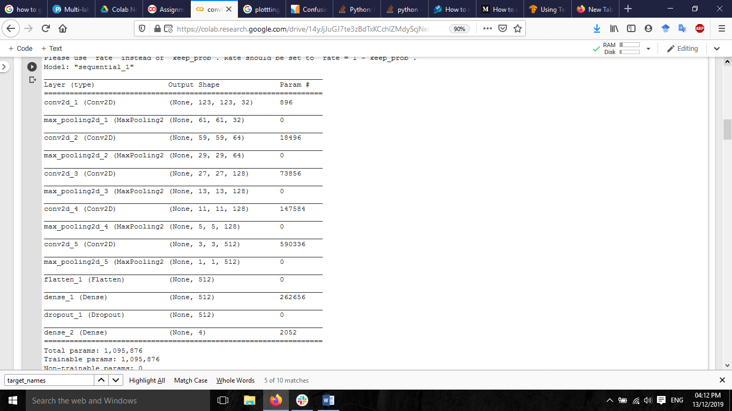First run with model summary shown In Fig. 2

Fig. 2: Model Summary

# Training Settings

|  |  |
| --- | --- |
| **Parameters** | **Value** |
| **Number of classes** | 4 |
| **Training Set** | 500 Images in each class, 500*4 |
| **Testing Set** | 200 Images in each class, 200*2 |
| **Validation Set** | 200 Images in each class, 200*2 |
| **Loss** | Categorical Cross Entropy |
| **Optimizer** | Adam |
| **Metrics** | Accuracy |
| Target size | 125,125 |
| **Steps per epoch** | 100 |
| **Number of epochs** | 10 |
| **Validation Steps** | 50 |
| Drop out | 0.3 |

# Outcomes at Epoch

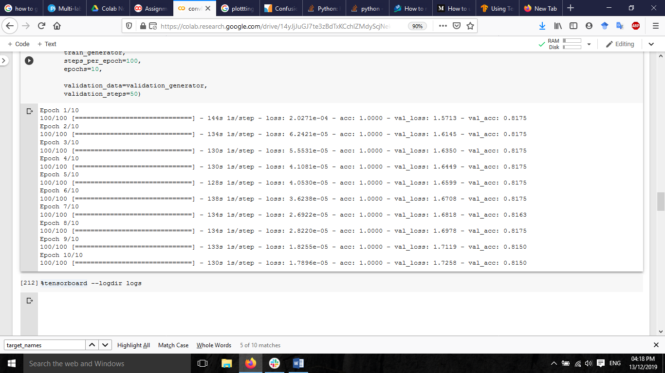

# Confusion Matrix

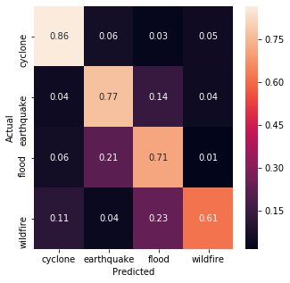

# Classification Report

# Training and validation performance graphs

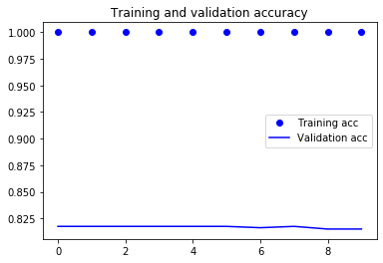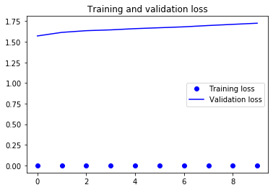

# Training # 3 with Model/ Network Summary

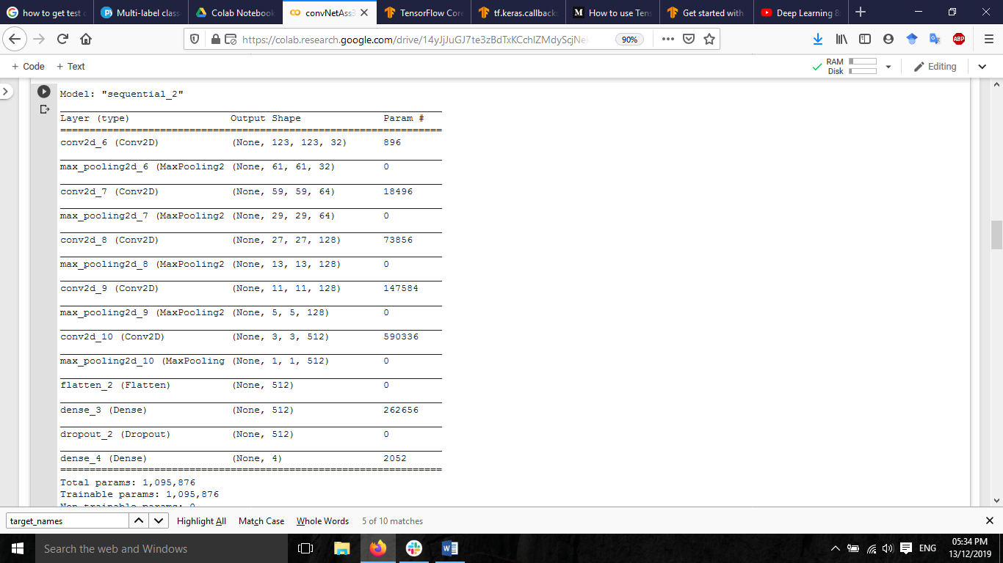First run with model summary shown In Fig. 3

Fig. 3: Model Summary

# Training Settings

|  |  |
| --- | --- |
| **Parameters** | **Value** |
| **Number of classes** | 4 |
| **Training Set** | 500 Images in each class |
| **Testing Set** | 200 Images in each class |
| **Validation Set** | 200 Images in each class |
| **Loss** | Categorical Cross Entropy |
| **Optimizer** | Adamax |
| **Metrics** | Accuracy |
| **Training batch size** | 50 |
| **Target size** | 125,125 |
| **Validation batch size** | 50 |
| **Steps per epoch** | 100 |
| **Number of epochs** | 10 |
| **Validation Steps** | 50 |
| **Drop out** | 0.3 |

# Outcomes at Epoch

# Confusion Matrix

# Classification Report

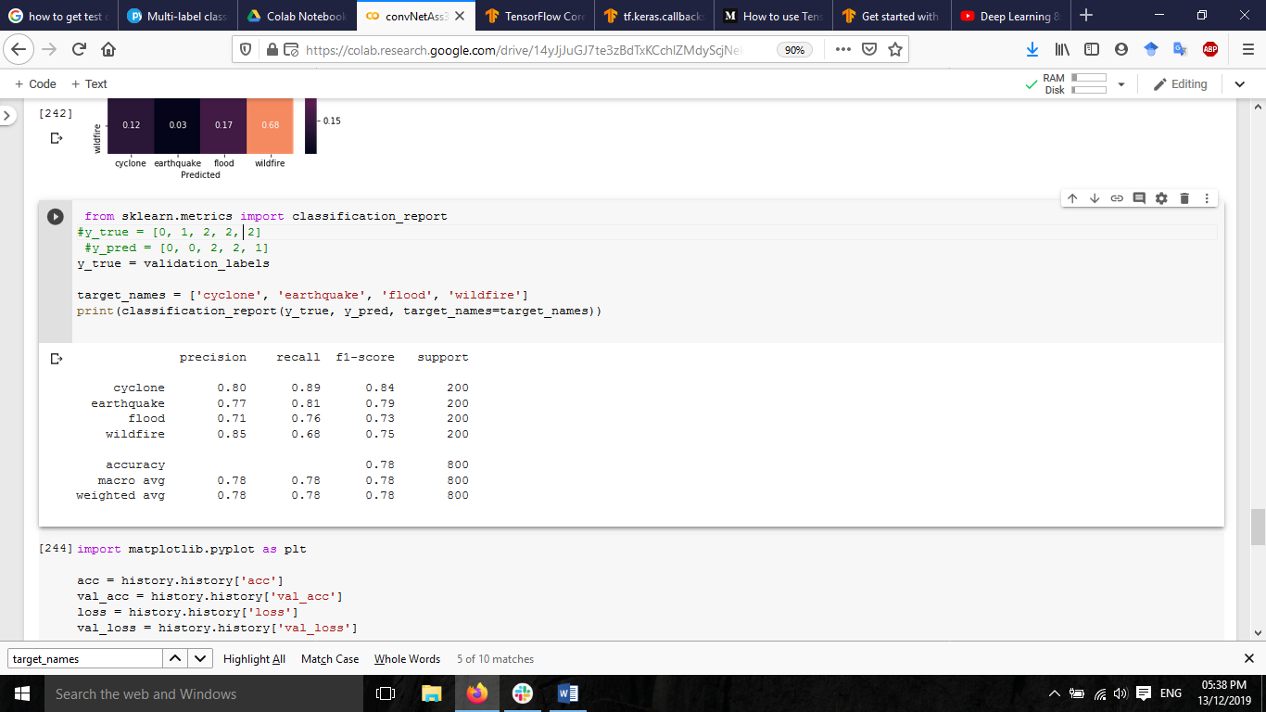

# Training and validation performance graphs

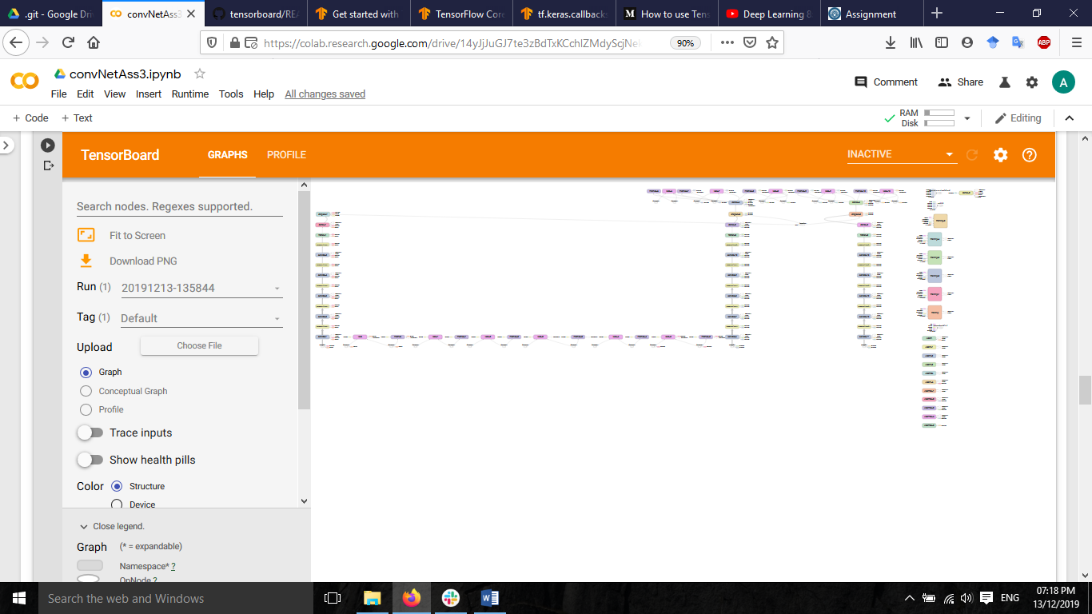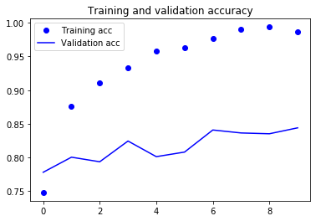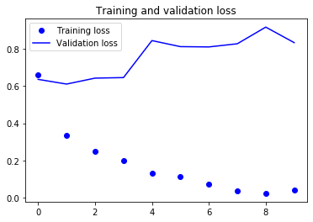

# TENSOR BOARD MODEL